G&L Motion Control
MMC-SD Application Note

Document Number: AN0052

Topic: Tuning the MMC-SD Position Loop

Scope
This Application Note applies to the MMC-SD Digital family of products.

Purpose

This Application Note provides information on tuning the MMC-SD position loop.

Introduction

The velocity loop was tuned from PiCPro using the drive control panel and with the controlling ladder diagram in the digital MMC card stopped. Position loop tuning uses the ladder diagram to provide the motion needed to tune. The ladder diagram must be able to initialize the servo function and close the position loops as well as cause the tuning motion.

The position loop operates by continuously comparing the target (command) axis position with the actual axis position. The difference between these two is the position or following error. In order to make the axis move, the command position is changed (iterated) as required by the type of move being commanded. The output of the position loop is the drive speed command. It is made up of several components that can be controlled by the tuning parameters.
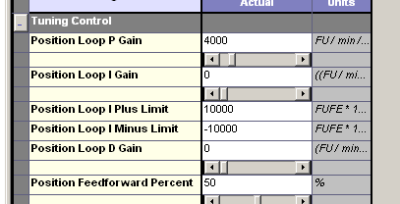
The position loop tuning parameters that are available are
- Proportional (P) gain
- Integral (I) Gain
- I Plus Limit
- Minus Limit
- Differential (D) Gain
- Feed forward %

When tuning, it is easier to type in the numbers and hit Enter than it is to use the sliders.

The proportional gain is multiplied by the position following error and becomes one component of the speed output command to the drive. The units of this gain are feedback units (FU) per FU of following error. In the machine tool world in particular, it is common to refer to this gain setting not in FU terms, but as inches per minute per mil. Inches per minute (ipm) is the speed being generated per mil (.001”) of following error. The range of this setting is typically 1.5 ipm per mil up to 5 ipm per mil. What this means is that at the gain setting of 3 ipm per mil, if the axis is traveling at 30 ipm, the actual position will track .010” behind the command. If the speed is doubled, then the following error will need to double to produce the required speed output from the position loop. The use of FU in both numerator and denominator of the gain settings requires that we multiply the ipm per mil values by 1,000 to get the values to use here, so a range of 1,500 up to 5,000 should be possible for the P gain setting.

The integral gain comes in to play at low speed or at standstill only. Its purpose is to eliminate any long term constant error by adding to the speed output until the error is reduced. For example, assume an axis is stopped and has a following error of 50 FU. This may not generate enough output from the proportional gain element to overcome slide friction. So the integral gain keeps building the output until there is enough generated to get the axis moving to its commanded position. Because of the integrating (incrementing) output action, it is desirable to limit the amount that the integral can contribute in order to prevent excessive amounts of output. This is the purpose of the position loop integral plus and minus limits.

The differential gain is typically left at 0 and not used. Consult Technical Support for more information.

Feed forward % is used to compensate for the situation described earlier where use of the proportional gain to create the speed output causes the axis to lag further behind the commanded position as the speed is increased. In cases such as axes that move to a position and stop there, with no requirement for accurate position control during the move, feed forward typically serves only to speed up a move. The penalty of its use may be that the axis overshoots position and has to reverse to its endpoint.

In master – slave situations or on equipment where it is important for axes to maintain an accurate position relationship during motion at different speeds, feed forward is usually required. It operates by looking at the commanded speed of the axis and then calculating its set percentage of that speed and feeding it forward to the output of the position loop. So if 80% feed forward is chosen, 80% of the commanded speed is given to the position loop output by this mechanism and only 20% then needs to be made up by following error. As a result, the axis stays closer to the commanded position at all times during the move.

Causing Motion

Motion must be caused from the ladder diagram and the type of move used should be chosen depending on the application requirements.

If the axis needs to make positioning moves, then settling time and overshoot are likely to be the important criteria. If the axis needs to maintain close position relationships with other axes through a range of speeds, then minimum following error is needed.

For positioning applications, pick the most demanding move the machine has to make and create the program to cause it to happen. Typically this will be a Distance move block. Calculate the acceleration, deceleration, speed and distance you want to use and also the time you want the move to happen in. Using 1/3 of the time in each of the acceleration, constant speed and deceleration segments simplifies calculations. This is because it results in 1/4 of the distance being spent in the acceleration and deceleration segments and the remaining 1/2 in the constant velocity portion of the move.

If you want a reversing move, set up 2 - Distance blocks to repeatedly cycle after each other once the axis is inside the in position band. Use timers between the blocks if you want to see the axes stop and settle each time.

For follower applications over a speed range, choose an acceleration rate that allows sufficient time to see the following error trace.

You will need a ladder input switch mechanism to trigger the motion and a way to stop it quickly and safely.

Observing the Motion

The drive oscilloscope function will be used to observe the results. After selecting it, also select Mode – Tuning so the tuning parameter adjustments are available.

Choose the information for the channel displays based on the type of equipment you are running and the results you want to get. In tuning the velocity loop earlier, the commanded and motor velocities were used. These may still be useful traces to observe, but actual and commanded positions as well as position error are also available. The command and actual positions are internal drive position values and their increment is 1 FU. This is the same as 1 ladder FU. Apart from the same resolution however, the numbers seen in the drive won’t be the same as the value seen in the ladder and cannot in any way be changed in the ladder. The drive value may be any number depending on how much motion the drive has done since its last power up. In order to see it on the oscilloscope with useable scaling, the Offset field in any channel being used to display position must be set to the value in the counter at the start of move position. With a bidirectional tuning move, that only needs to be done once. However, with a unidirectional move it must be done for each new move, since the position will be incrementing each time. The oscilloscope will trap the results regardless of values or offsets and the trace can be brought on screen by changing the offset at any time once capture is stopped. So round numbered moves will be helpful in this situation.

Once a position is chosen on one of the oscilloscope channels, select Run Continuous so that the oscilloscope runs. The current position value will be seen in the Channel Definition display area under the oscilloscope screen. Type the value in to the Offset fields in the channels being used for position display.

Position error will display without any offset being needed. The In Position bit from the ladder that turns on when there is no move in progress and the actual and command positions are within a range set in the servo setup file is also a useful signal. In order to show this on the oscilloscope, the bit must be mapped to a drive output in the ladder diagram. This is the signal most commonly used to determine when a move has actually completed. Otherwise, the motion may be considered complete when the command position has stopped iterating.

Sample Tuning Procedure

This is an example session for tuning a system where positioning time is important and no position overshoot is permitted. It tries to illustrate some of the issues, settings and tools available. You need to be aware of the results you are trying to achieve and adapt the techniques you use to suit these goals.

Leave the velocity loop gains and the inertia ration entry as they were set during velocity loop tuning. Do not adjust them other than during the velocity loop tuning procedure.
Use these initial position loop settings:
P gain 1500; I gain 0; I Plus Limit 0; I Minus Limit 0; Feed forward 0%
Accel feed forward, drive accel / decel limits off, low pass filter inactive

The following examples were taken from a motion simulator using a YSM 102 motor with a larger disk wheel for extra load. The inertia ratio measured 8.77:1, which is a fairly large mismatch from the ideal of 1:1.

Since we are causing motion in the ladder world and observing results in the drive oscilloscope world, some manual conversion of units is needed to relate the two.

The oscilloscope uses RPM for speed; the ladder uses ladder units (LU) per minute.
The oscilloscope uses feedback units (FU) for position; the ladder uses the same FU.
The oscilloscope does not show acceleration but there is a programmable limit in the drive in RPM per min per sec. where the ladder uses FU per min per sec for acceleration.

A UDFB called M_TUNCLC was used to allow different moves to be set up based on time and distance. It calculates velocity and acceleration (deceleration is the same value) from time and distance inputs. Time allowed is divided equally between acceleration, constant speed and deceleration segments. This allocation of time means that distance in the 3 segments works out at ¼, ½ and ¼ and simplifies the math considerably.

You do not need to use this block. Use the values for the most demanding move the axis has to make. Use linear acceleration while tuning and set the position error limit high. Turn on fast queuing so the move starts iterating immediately

The motor encoder is 2000 lines, giving 8000 feedback units (FU) per rev.
Ladder units (LU) are set a 1/8 of FU, so there is 1000 LU per rev.

A UDFB called M_POSTUN was used to cause motion. It initiates Distance moves in either the forward or reverse directions or both, with a selectable time delay between the moves.
A distance of 1000 will be used in all moves. In position band is 125 FU.
The charts should print in color if necessary for better understanding.
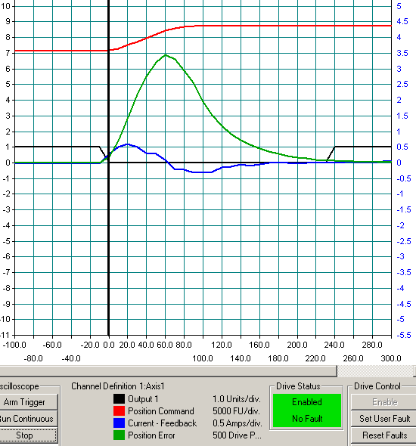
The move time programmed is 100 ms. This results in a constant velocity target of 450 rpm and acceleration of 27 million LU per min per sec. The sample time is 10 ms. Output 1 is the in position signal and is the one starting at level 1 on the left hand scale. It is an on - off signal and should look like a square wave. The slope on its edges is just the effect of the 10 ms sample time. Measuring its cycle we come up with -10 ms to 230 ms or 240 ms. The theoretical time should be 100ms. The top trace is the command position and we can see it completes in the 100 ms time frame. So the actual move took much longer than the commanded one. The current is the lower of the other 2 signals, peaking at 0.5 amps. The other is the following error, peaking at 7 x 500 = 3,500 FU.

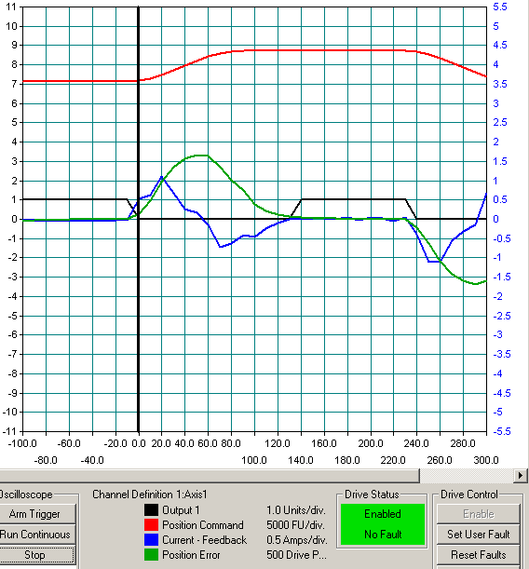
The only change here is the P gain of the position loop is now at 4000 (4 ipm per mil). The in position time has come down to150 ms or so but is still well outside the theoretical of 100 ms. Current has now risen to a 1 amp peak. Position error now peaks at 1700 FU.

We could continue to raise P gain until instability is seen, but let’s see the effect of feed forward next.

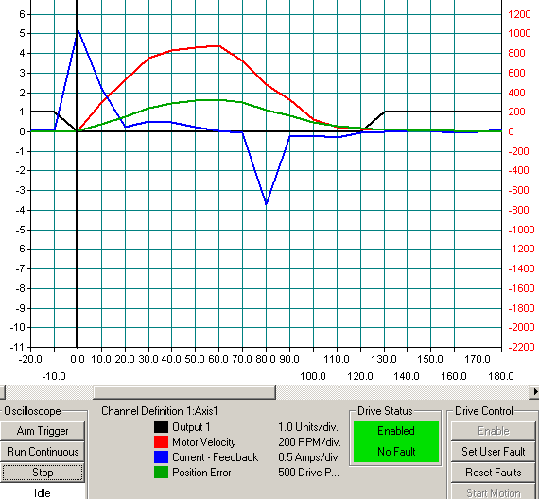
In this case, the P gain is still at 4000 but feed forward is set to 50%. The time has come down to 120 ms or so, but peak current (triangular wave) has doubled to 2.5 amps.

Position error peaks at 800.

We may be asking more of the motor that it can reasonably achieve with its present 8.77: inertia ratio load.

This may not be a good tuning condition, so let’s double the time allowed to 200 ms.

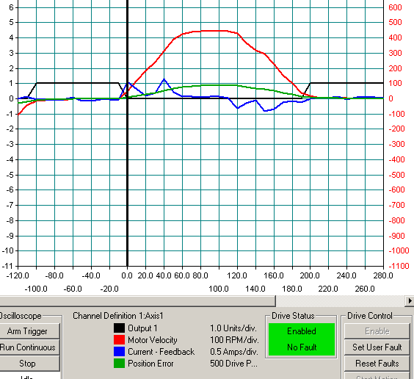
By doubling the time allowed, the constant velocity rate required is now only 450,000 LU per min or 450 RPM and the motor speed comfortably reaches that in the target setting of 1/3 of the time. The in position signal is around 200 ms and so the move is made in the target time.
Position error has dropped to a maximum of 500 FU.

We can see the effect of the P gain and feed forward % from the amplitude of the motor velocity in RPM and the position following error in FU.

The peak speed of 450 rpm is coming 50% from the P gain times the position error and 50% from feed forward. So 225 RPM or 225 x 8,000 = 1,800,000 FU is equal to P times the following error. Calculate 1,800,000 / 4000 = 450 FU of following error. The amount shown on the trace is just under 1 division at 500 FU per division, so theory and practice agree.

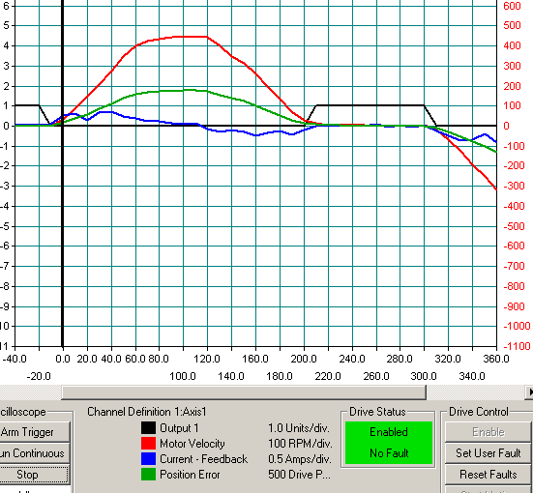
P is still at 4000, feed forward has been set to 0% and time has gone out by 10 ms or so.

Following error has doubled to 850 because all the speed command must now come from following error

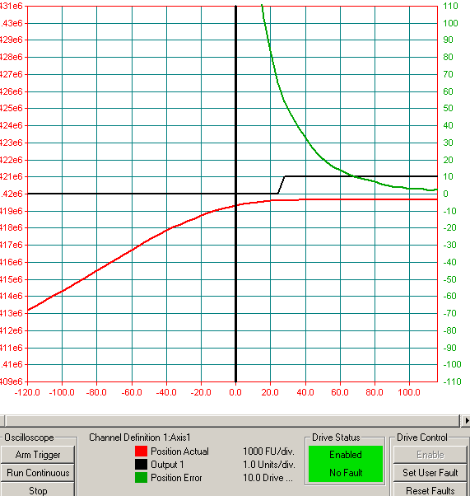
Here we are back to P at 4000 and 50% feed forward. The oscilloscope is set for 4 ms capture rate and triggering is set and delayed so the approach to the in position point is seen in more detail. The top trace is the position error and the bottom one is the actual position. There are no signs of overshoot as we hit the in position band, so we can accept what we have or continue tuning or trying different move times and distances.

Remember to turn the Low Pass Filter back to Active and save the settings to a DDV file before finishing. Now we need to decide on a following error limit setting for our ladder diagram. There is an error detected by the servo software that detects if the following error exceeds a limit value. This is set in the Axis Data / Position Data tab of the servo setup but can also be written in ladder with a WRITE_SV function of variable 39. Note that WRITE_SV uses FU, where the servo setup uses axis units. Setting a good value provides additional machine protection against jams or other overloads. Setting too low a value may cause nuisance trips. The error may be high during acceleration periods also. So what is a good value? Examples on how following error works with the loop gain settings and feed forward have been given above, so the maximum value can be calculated from the top speed or it can be observed from the oscilloscope readings. How much margin is allowed is a machine specific situation. The likelihood and potential severity of damage needs to be taken in to account in making the decision. The other safety device in this area is the drive current limits and fault trip settings. In general, servo motors and drives are oversized for their applications, so leaving them at their default levels is not a good idea. Make sure you measure the maximum current required and set the limits and fault trips to provide maximum protection.

If the application is not concerned about positioning time or overshoot, such as an axis that must track a master at all speeds without their position relationship changing too much, then a different move type such as a triangle or a sine wave might be more appropriate.

If you think you require acceleration feed forward, please call Technical Support.

Revision History

Date: July 31, 2026
Author: John Boyle
Changes: Original

Date: [For each revision, enter the date revised,]
Author: [the name of the person revising the document,]
Changes: [and indicate what changes were made.]

